# 1.0 Introduction:

The data that is going to be analysed consists of information regarding the total number of copies of video games that have been sold all over the world between the years 2000 and 2020. There are 16599 rows of data to help organise the information, and there are 15 columns to help with that. These pieces of information are contained inside the columns:

|  |  |
| --- | --- |
| Columns | Description |
| Rank | Ranking of overall sales. |
| Name | The name of the game. |
| Platform | The platform on which the game was released (i.e. PC, PS4, etc.) |
| Year | The Year The Game was Released. |
| Genre | The Genre of the Game. |
| Publisher | Publisher of the Game. |
| NA Sales | Sales in North America. |
| EU Sales | Sales in Europe. |
| JP Sales | Sales in Japan. |
| Other Sales | Sales in the rest of the world. |
| Global Sales | Total sales from all over the world. |
| Critic score - | Total rating compiled by members of the Metacritic crew |
| Critic count | Number of reviewers utilised to calculate Critic score |
| User score | Score determined by the users who subscribe to Metacritic. |
| User count | The total number of users who contributed to the user score. |

Excel was used to remove all NULL values, duplicates, and gaps in the data (such as when just part of a name or a year was provided), as well as correct certain incorrect dates associated with games. This action was taken to improve the reliability of the data.

# 2.0 Data Analysis and Visualisation:

## Declining Trend in the video game market.

## 1.Total Sales by Year:

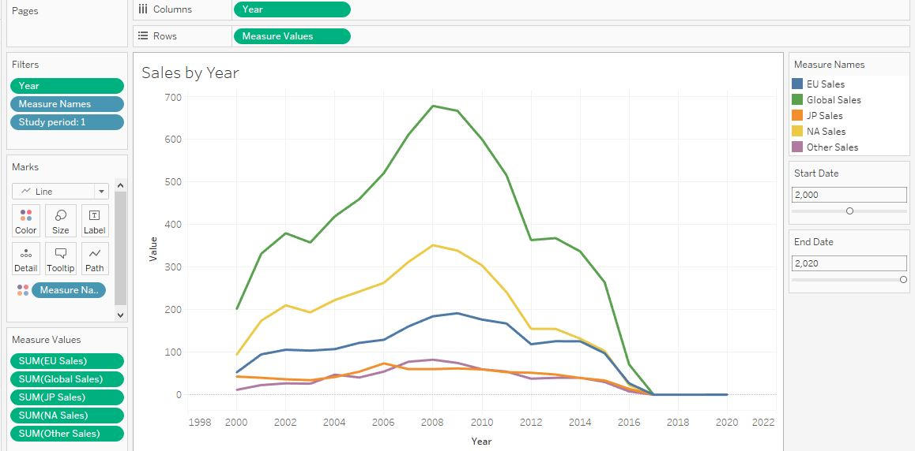

Figure 1. Video Game Sales by Year

## 2. Top 5 Video Games Sales by All Markets.

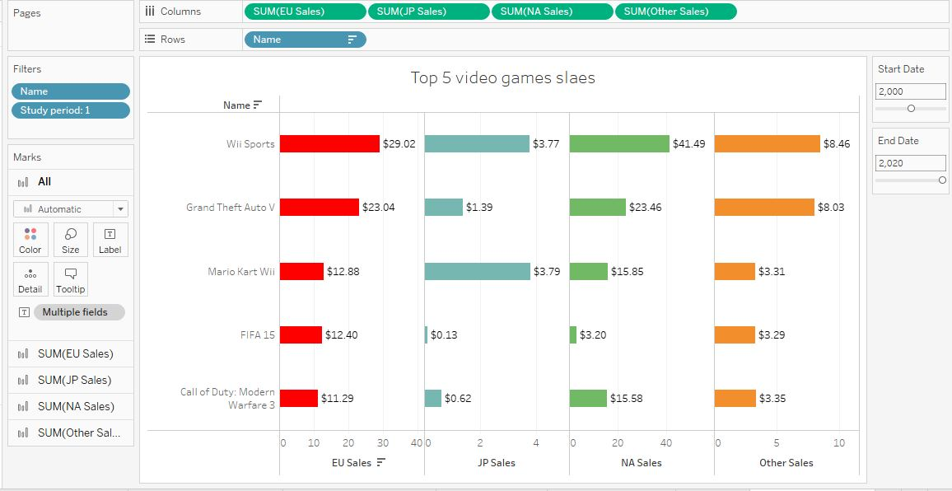

Figure 2. Top 5 Video Game Sales

## Top 10 Platform Global Sales

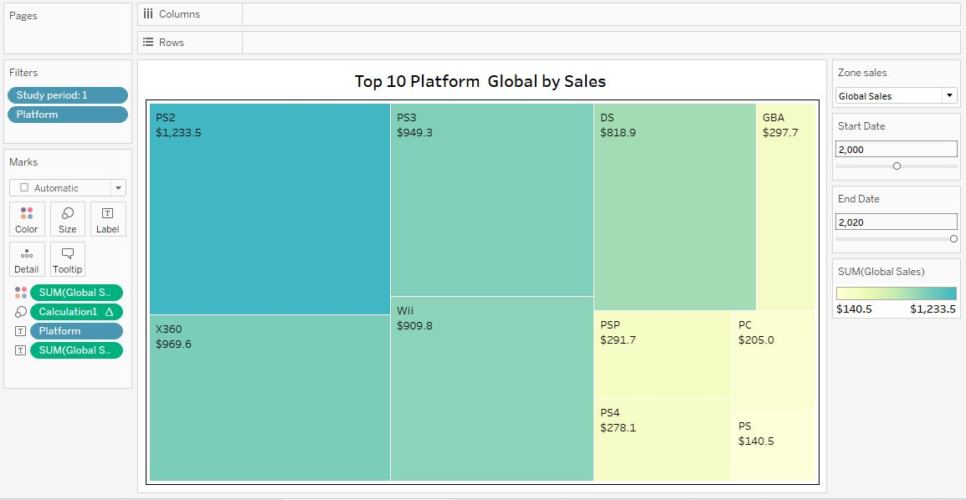

Figure 3. Top 10 Platform Global Sales

## 4. In terms of sales, action games dominated.

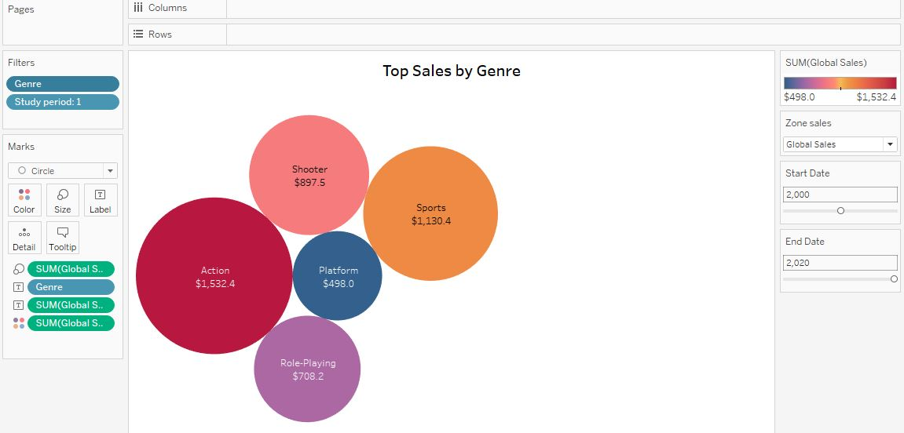

Figure 4. Top 5 Genre Global Sales

## 5 Top 10 Publisher by Sales

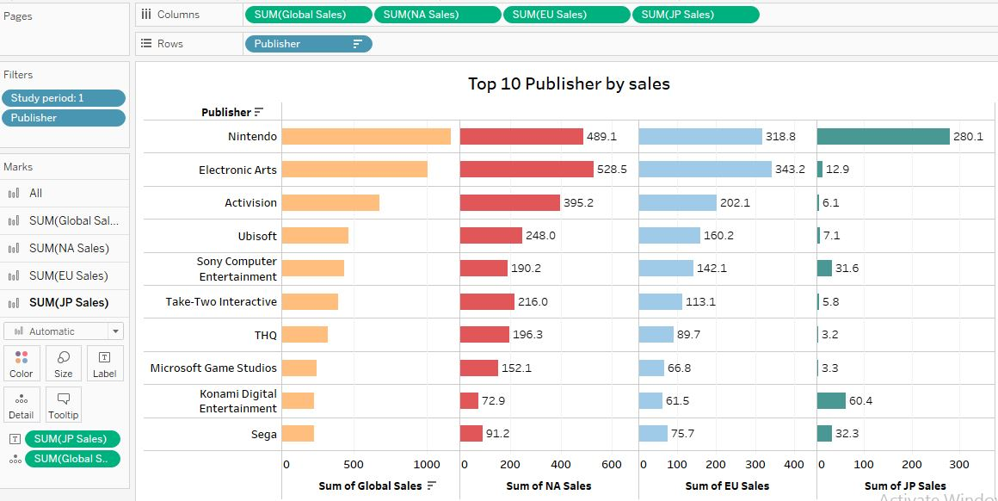

Figure 5. Top 10 Publisher by Region Sales

## 

## 6 Best-selling games in top 5 Genre and Platforms

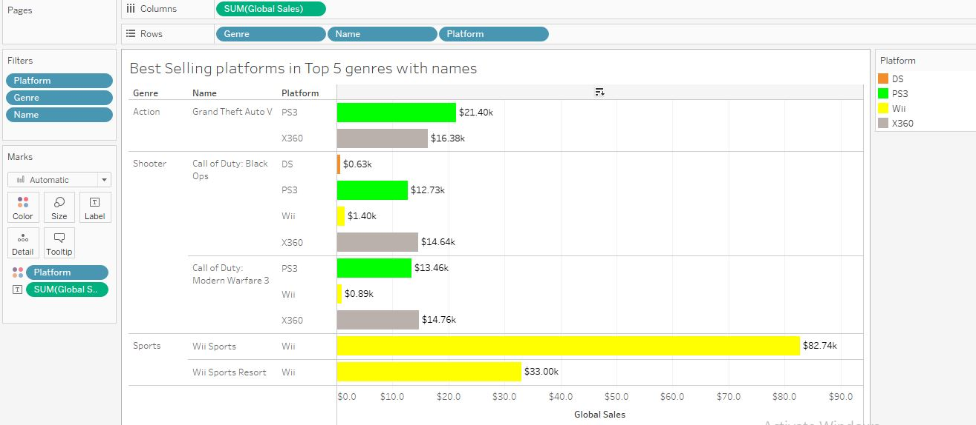

Figure 6. Best-selling games in top 5 Genre and Platforms

## 7. Yearly Sales of NA and JP Market.

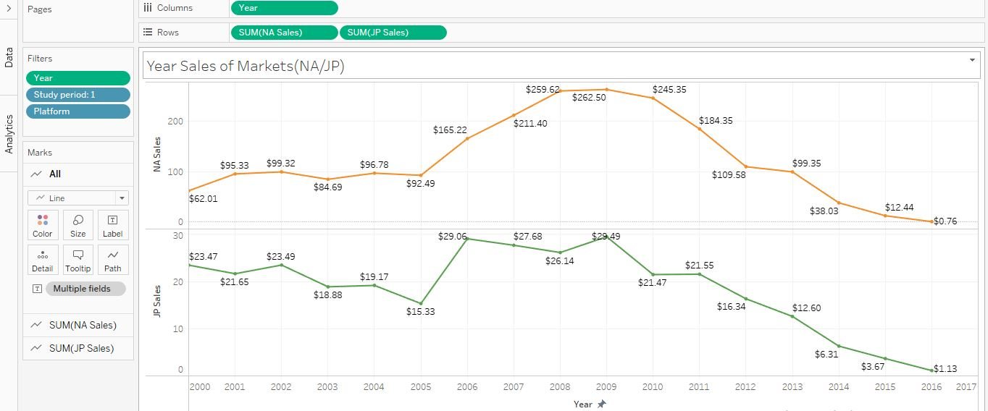

Figure 7. Yearly Sales of NA and JP Market

## 8 Comparing European and Japanese Publisher Top 10 Sales.

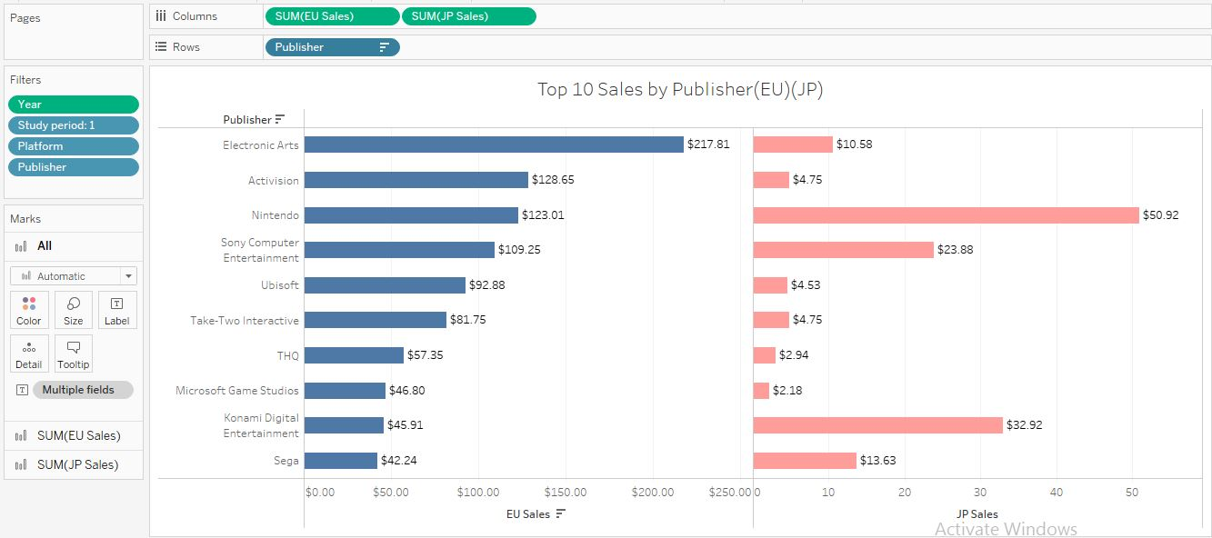

Figure no:8 Comparing European and Japanese Publisher Top 10 Sales.

## 9. Comparing Top 5 Genre Sales of EU AND JP sales.

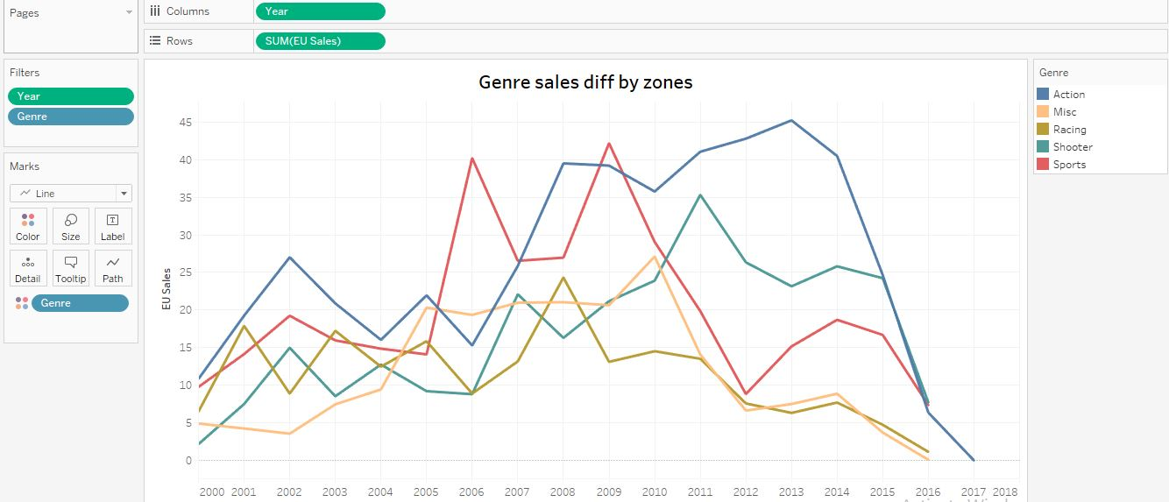

Figure no:9 Top 5 Genre Sales of EU

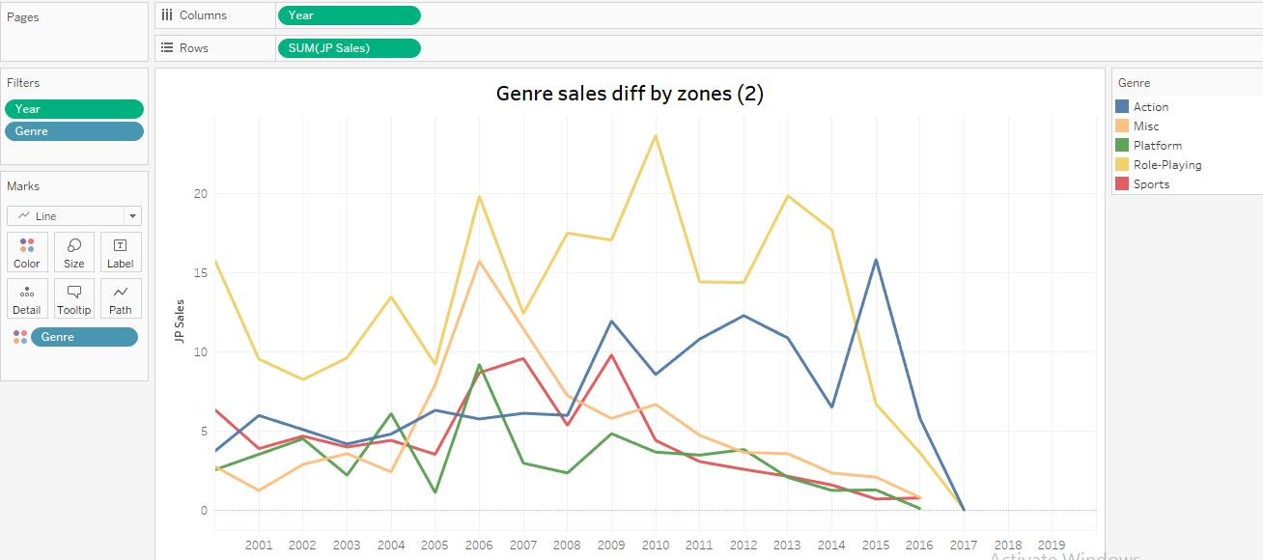

Figure no:9.1 Top 5 Genre Sales of JP

\

## Data Mining

## 3.1.1 Trend Lines

## 1. Global Market sales.

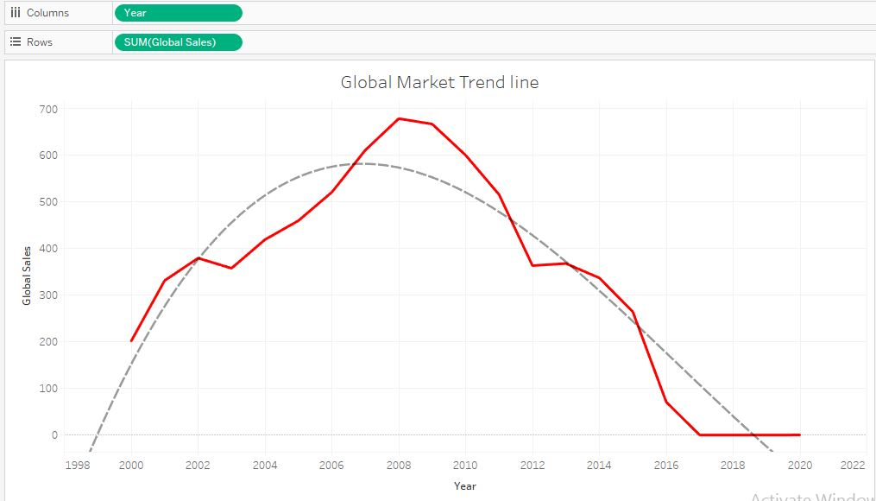

Fig no:1 Global Market Sales trend.

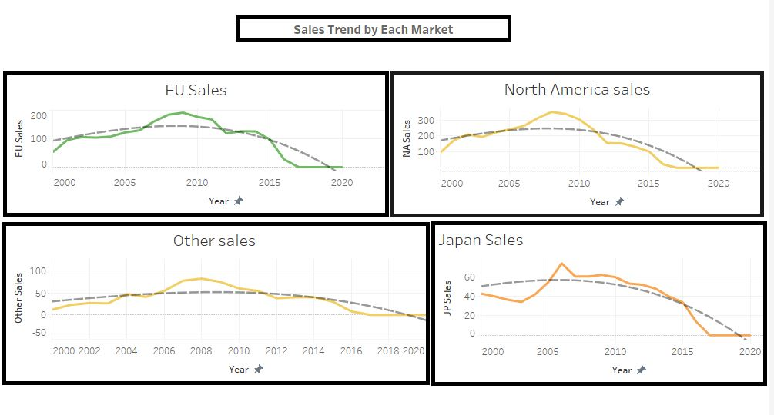

Fig no: 2 Trend by All Market Sales.

## Year platform SALES of Market (NA/JP)

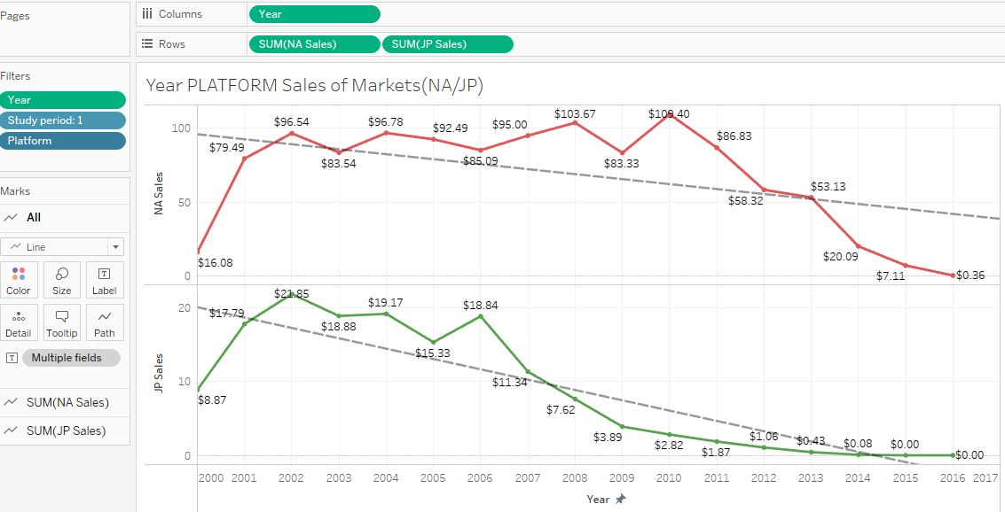

Fig no:3 Platform sales in Markets of Japan and North America Sales trend.

## Sales by year and genre of Japan and European Market

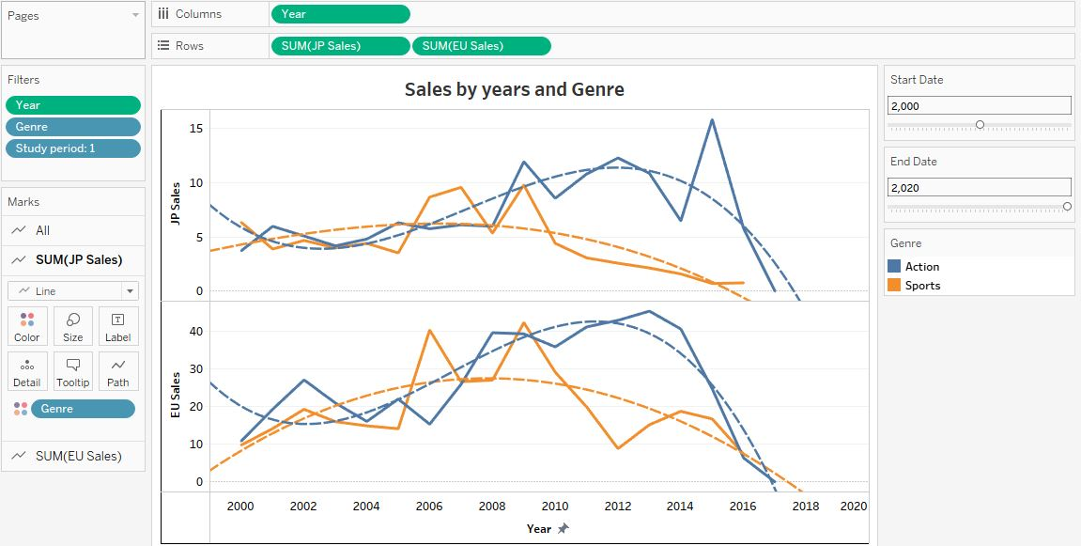

Fig no: 4 Sales by year and genre of JP and EU

# 3.1.2 Forecast

## Global sales Forecast

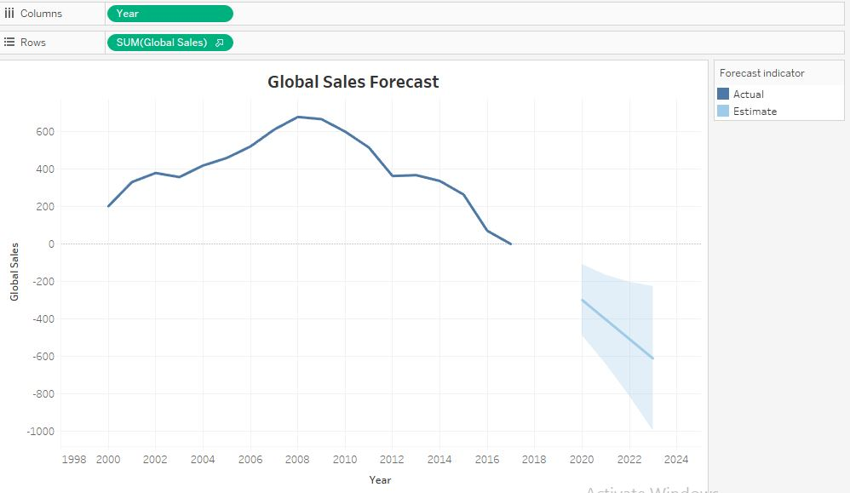

Fig no: 5 Global sales Forecast

## Yearly sales Forecast for all Markets:

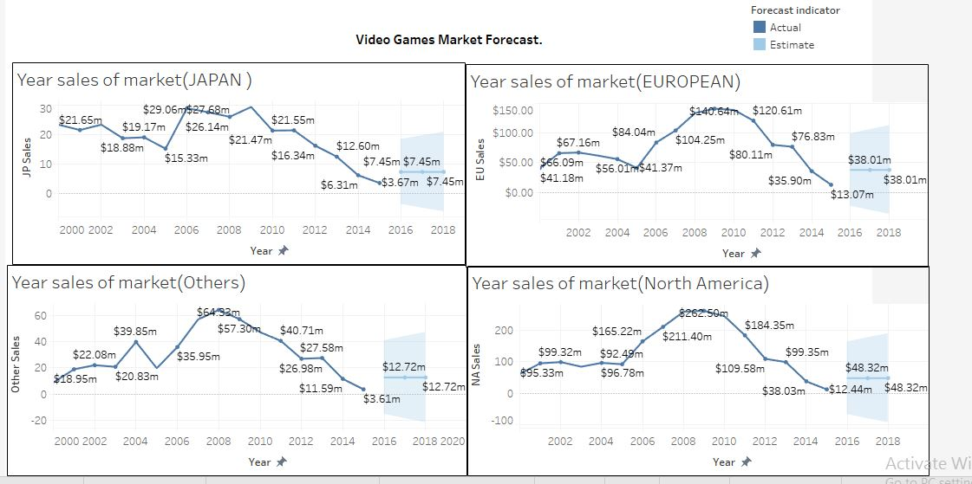

Fig no: 6 Forecasting of All 4 Markets

## Top 2 Games Publisher with Critic Score.

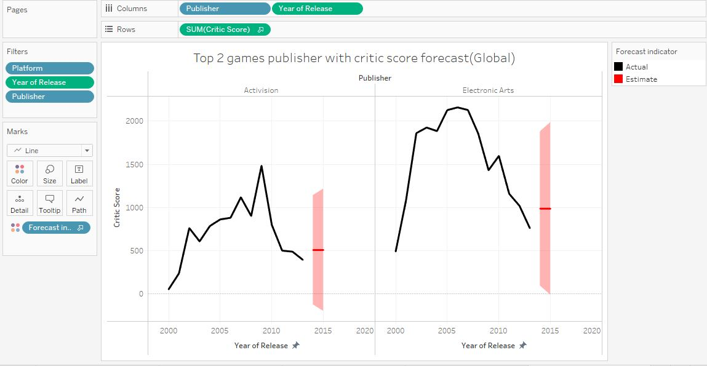

Fig no: 7 Best 2 Games Publisher with Critic Score.

## Comparing Between European and Japan Yearly sales of Genres.

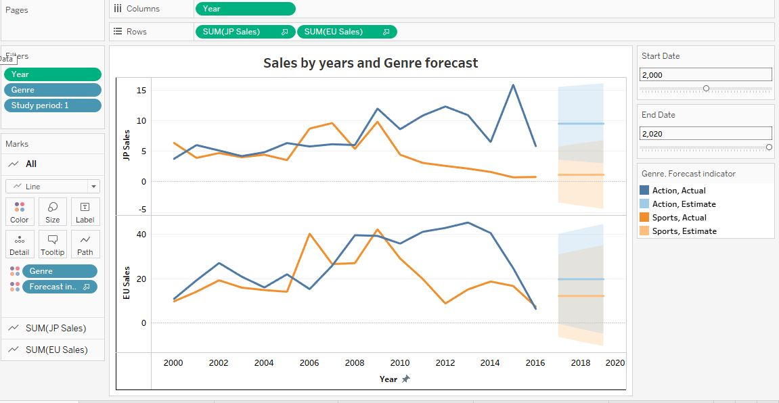

Fig no: 8 Comparing Between EU and JP Market Yearly sales of Genres.